Education

Vasyl Symonenko Lyceum 2008-2019

Specialty Applied Linguistics. Ivan Franko National University of Lviv : (2019- currently studying )



**SoftServe | IT Academy HTML5/CSS3/JavaScript Fundamentals |July 12, 2019 – August 16, 2019**

I am calm, responsible, sociable and persistent. I can easily connect with people and the team. I am interested in the field of IT, namely web development .

About me

Ukrainian, Russian - native

English – Intermediate (B1)

Language

My GitHub:

https://github.com/Romandenusiv



Courses

Skills

Lviv,Ukraine

+ 380 (066) 343 13 15

Gmail: [romanfedusiv@gmail.com](mailto:romanfedusiv@gmail.com)







**Contacts**

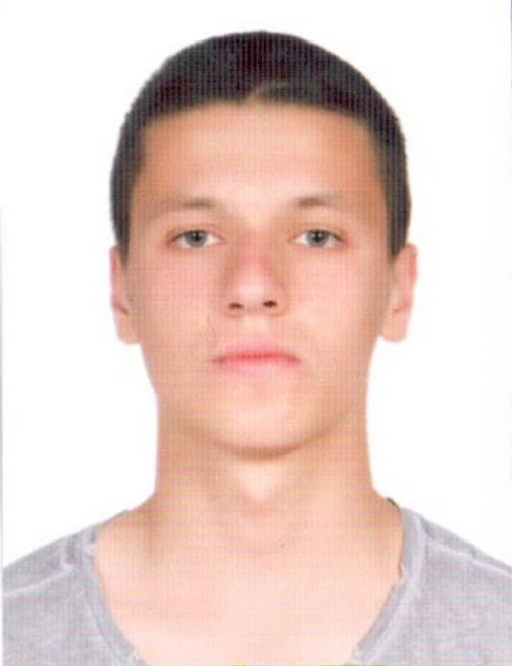

HTML, CSS3/SASS, Java-Script, React, NPM, Python, Git

Roman Fedusiw

Front-end developer/JS developer